User Manual

Principal Investigator: Alex Wong, PhD, DPhil, FACRM
Funded by: Craig H. Neilsen Foundation

Table of Contents

About the Study 3
What To Expect 4
How to Use the iPhone
- Start the survey 5-6
- Select an answer 7-8
- Speaking an answer 9
- Active Tasks 10-11
- End a survey 11
Help 12 General Common Questions and Answers 12-13
EMA-Specific Questions and Answers 13

About the Study
Thank you for taking part in this study. You will participate in a study that aims to understand daily experiences and identify the key factors affecting social life. The information gathered will help develop a timely, personalized support intervention for individuals with SCI.
We will either provide you with an iPhone, or you will use your own iPhone with the App called “Gene Doe” installed (Page 4; Image 1). Over the next 14 days, the study App will alert you at random times to complete 5 surveys each day. For each survey, you will answer questions about your current activity, who you are with, and how you are feeling. You will also complete a mobile cognitive task, like a brain game, after the survey. Each survey will last about 3 to 5 minutes.

Contact us about any technical problems or questions:

Lorie Cashdollar
Senior Project Coordinator
Phone: 312-238-8046
Email: lcashdolla@sralab.org

What To Expect:
- Your iPhone will alert you five times a day. Alerts will be sent around 8 am–10 am, 11 am–1 pm, 2 pm–4 pm, 5 pm–7 pm, and 8 pm–10 pm. This is about every 3 hours.
- If you miss an alert, the survey will remain open for 1 hour. We will send 3 reminders, each 15 minutes apart.
- After 1 hour has passed, you will not be able to go back. You will have to wait for the next survey.
- You MUST always keep the iPhone with you and charge it every night.

Image 1. iPhone with Gene Doe Installed
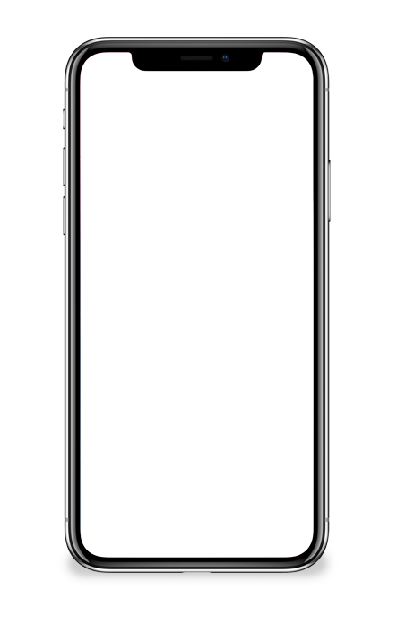
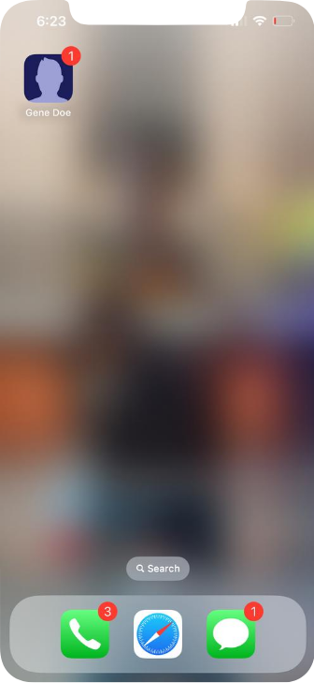

Volume Control

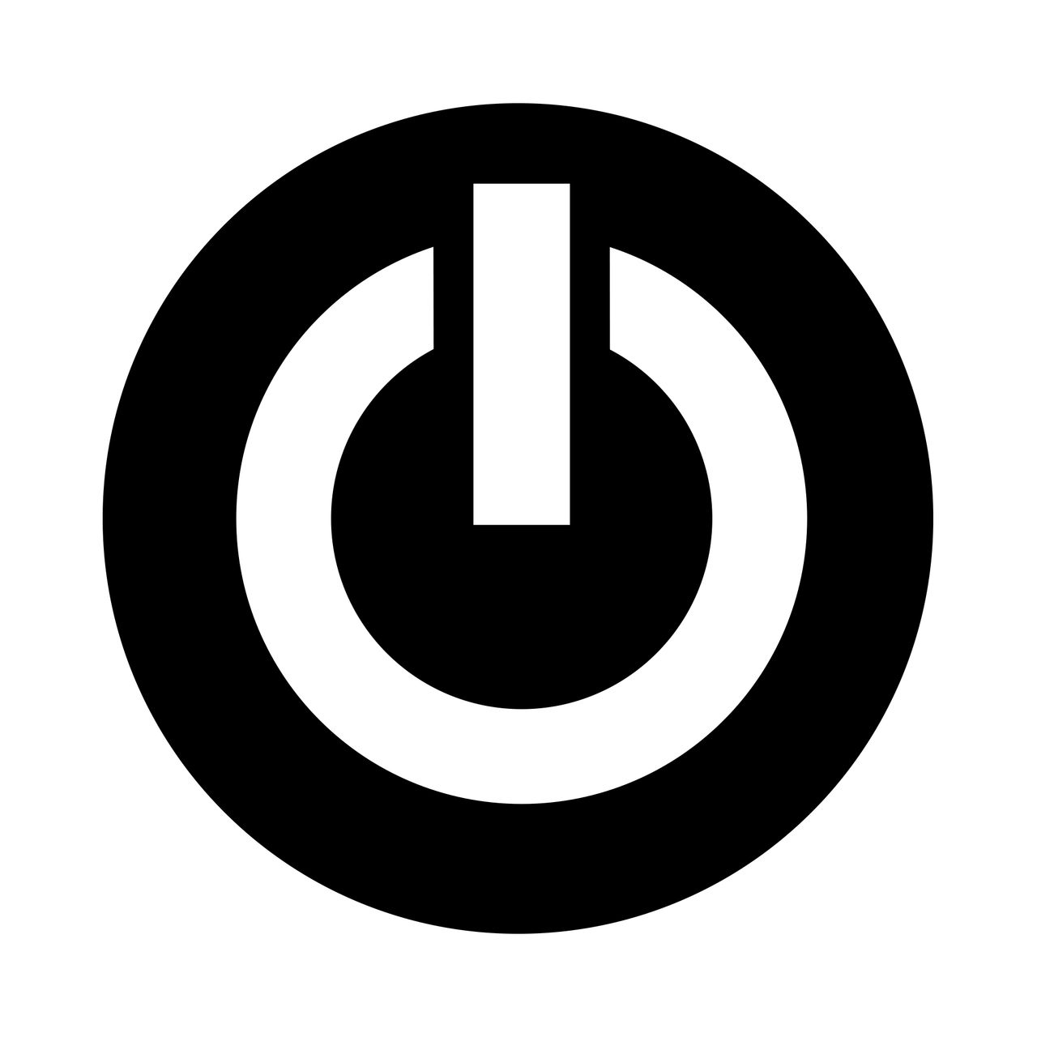
Power Button

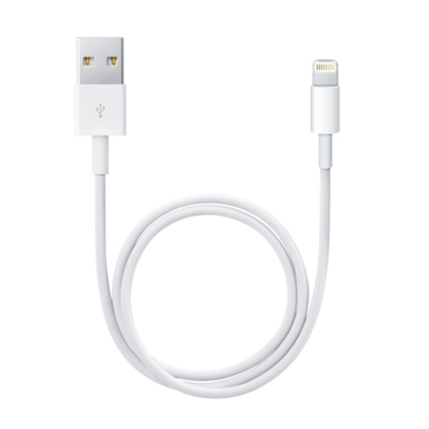
Charging Port
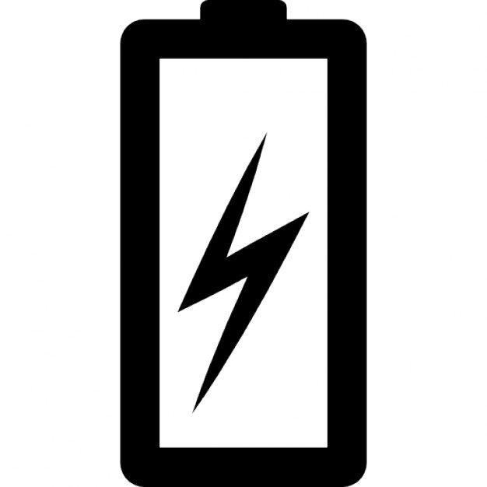

How to Use the iPhone

Start a Survey:
- When you have a new survey, you will receive a notification as pictured in Image 2.
- Once you receive an alarm/notification that you have a survey to complete, open the App by pressing the Gene Doe button or clicking the notification to start the survey.
- After that, an EMA session is waiting for you. The screen will look like the picture on page 6 (Image 3).
- To start the survey, click the banner

Image 2. Survey Alarm/Notification
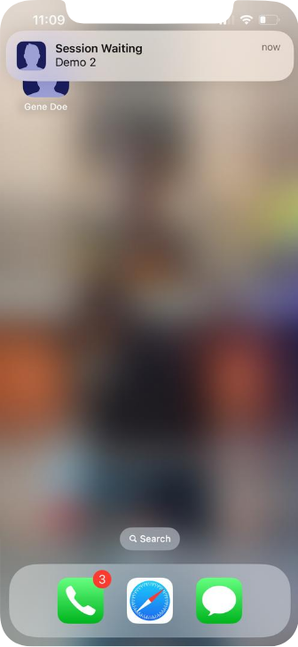

Click!

Image 3. Survey Waiting
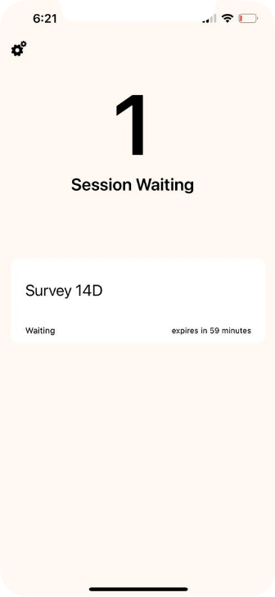

Click!

Select an Answer:
- After you open the survey, you will see a screen like the one below (Image 4).
- To respond, scroll and select your best answer.
- Some questions have too many options to fit on the screen. You may need to scroll down to see the extra options.
- Some questions allow you to select more than one answer. After you select all your answers, click "Next." (Example: Page 8, Image 5).
- The last question of the 5th survey each night will ask you to speak your response (Example: Page 9, Image 6).

Image 4. Select One Answer
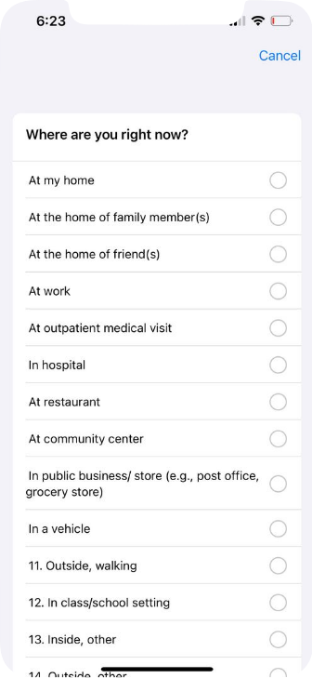
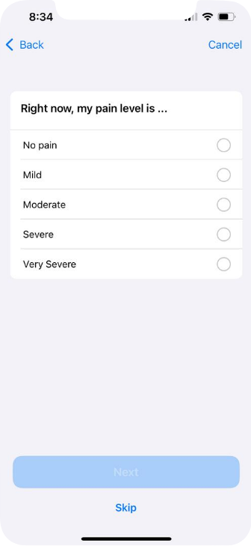

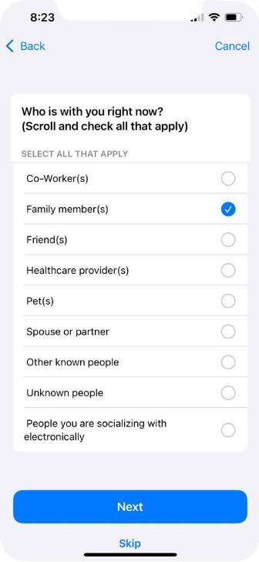
Image 5. Selecting More than One Answer
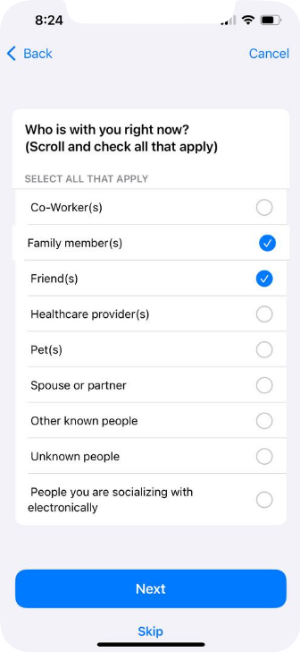
Click!

Speaking an answer:

If you are speaking into the device, please speak close to the microphone.

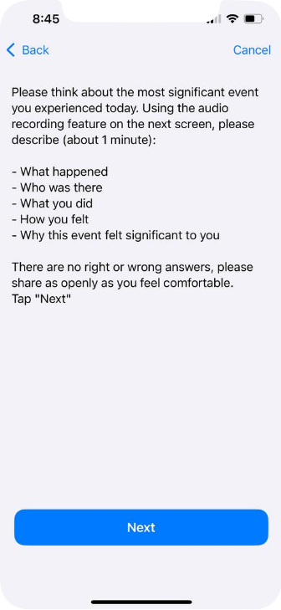
Image 6. Speaking response

Active Tasks
- We will see an Active Task after you complete the survey.
- Click “Next” to begin an Active Task as pictured in Image 7.
- After you complete an Active Task, your screen will say "Activity Complete," as pictured in Image 8 (Page 11)

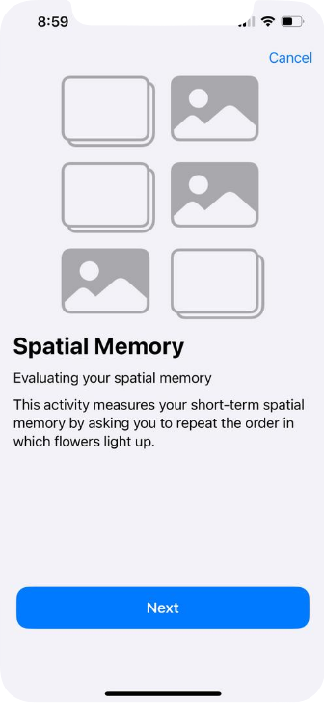
Image 7. Active Task (Mobile Cognitive Task)

Click!

Image 8. Active Task Completion
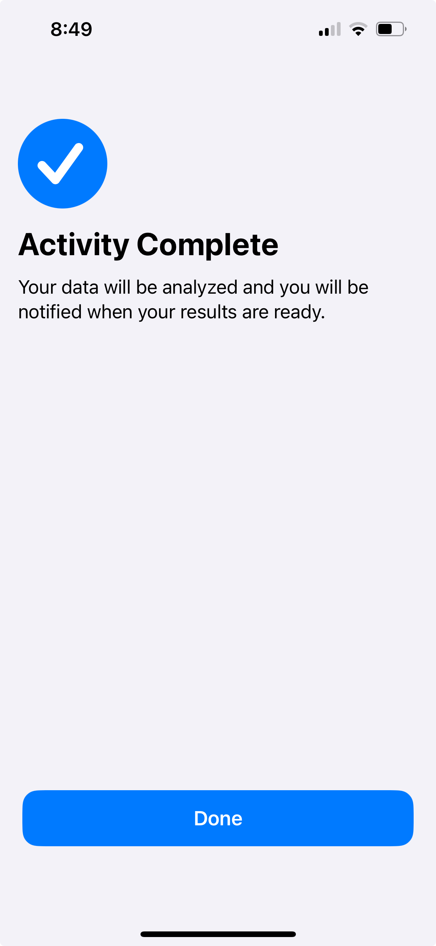

Click!

End a Survey
- You are completely done with a survey when the screen says, "Survey Complete" .
- Select "Done."
- You will see a screen that says, “Thank you for completing the session,” to indicate the completion of the whole survey.

Help
What to do if your iPhone stops working:
- If your iPhone has not alerted you at all today, make sure that it is charged. To do this:
  - Plug the charger into the charging port at the bottom of the iPhone (Example: Image 1, page 4).
  - When the iPhone is charging, there will be a lightning bolt next to the battery icon, and the battery percentage will increase.
  - If you still have problems, please contact the team at
312-238-8046 (Lorie)
We will call you back as soon as we can.

General Common Questions and Answers
- Can I use the lab-borrowed iPhone to make calls and texts?
No, you can't use the iPhone to make any calls or texts. All applications on the device are turned off except the EMA application.

- Can I use the lab-borrowed iPhone to surf the Internet?
No, you can't use the iPhone to surf the Internet. All applications on the iPhone are turned off except the EMA application.

- How can I tell if the battery is charged?
You can check whether the battery is charged by checking the battery status in the top right-hand corner of the screen (Image 1, page 4). The remaining battery percentage will be displayed next to the battery icon. If the battery icon at the top of the screen says 20% or less, we suggest that you charge it as soon as you can.

- Can I change the volume on the iPhone?
Yes, you can change the iPhone volume by pressing the buttons on the left side of the iPhone (Image 1, page 4). The top button raises the volume, and the bottom button lowers it. Make sure that the iPhone is loud enough for you to hear.

- What if the alarm goes off while I am driving?
We DO NOT want you to answer surveys while driving. Please ignore the alert if it goes off while you are driving.

- What should I tell people if they ask me what the device is for?
Some people are okay saying they are in a study and that this iPhone asks questions about daily activities, moods, and thoughts. Some people don't want to share this information. If you don't want to share, you could say you are using it to keep track of your schedule or listen to music.

If you are worried about what others will think about you using the iPhone, please let us know at 312-238-8046 (Lorie). We will gladly talk to you about using the iPhone in a way that is best for you.

EMA-Specific Questions and Answers

1)When answering the question, “Where are you right now?” or “What are you doing?”
If you just left a location or finished an activity, answer these questions based on what you have done since the last alarm.

