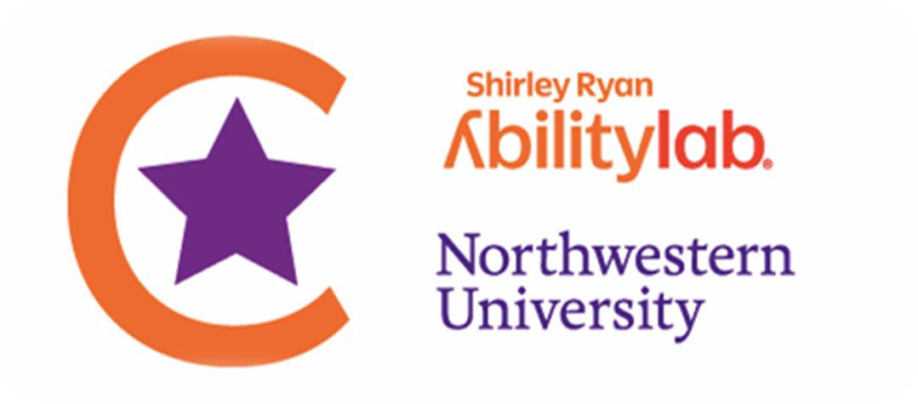
The Center for Smart Use of Technologies to Assess Real World Outcomes
355 E. Erie St, Chicago, IL 60611
email: cstarpilotprojects@sralab.org
sralab.org/cstar

2023 Pilot Project Program: Letter of Intent

Complete this form using Arial 11-point font, single-spaced. Do not alter margins or delete form text. Section 12 is to be completed only for resubmissions of a full grant application. Please submit the completed form at the REDCap link here.

1 | PI/Applicant Name  (first, last, degree(s))
2 | Academic Rank/Title
3 | Department & Institution/Organization
4 | PI/Applicant Email Address & Telephone
5 | Mentor/Co-Investigators (name, institution, academic rank, email address)
6 | Project Title
7 | Hypotheses and/or Objectives of the Project (300-500 words)
8 | Overview of the Study Design/Methods (300-500 words)
9 | List of References
10 | Please describe how you plan to use C-STAR resources to help advance your career in rehabilitation research. Description of C-STAR resources and areas of expertise: https://www.sralab.org/cstar
11 | Is this a resubmission of a previously reviewed (but not funded) C-STAR Pilot Project application (LOI and/or full application)? |  |  | Yes |  | No
12 | Resubmission (up to 500 words): If this LOI is a resubmission of a previously reviewed but not funded full grant application please respond to reviewer comments or discuss how you have improved the application to elevate the likelihood of funding.
13 | Include your NIH-style biosketch.  Instructions and template: https://grants.nih.gov/grants/forms/biosketch.htm

Submission Instructions: Click this link to submit your LOI by April 3, 2023.

